

25th Anniversary of the Cockrell Sundial: September 22, 2014

• Fall equinox, 1989 was the opening of the Cockrell sundial on the plaza of the Houston Museum of Natural Science.

• The basic layout was designed by Dr. Carolyn Sumners, Vice President for Astronomy and Physical Science of the Houston Museum of Natural Science

• Calculations of the exact positions of the shadow at the each daylight hour (mean sun, CST) for twelve months of the year, plus the calculation of the analemma, were supervised by Prof. Patricia Reiff of Rice University

• The silver ball to project images of the sun at solar noon on the equinoxes and solstices was designed by Dr. Reiff. The ball has three holes drilled for alignments at the solstices and equinoxes and lenses fitted so that the image focuses at a convenient height.

• Final adjustment of the ball location and orientation was accomplished Sept 22, 1989.

• Major funding from the Cockrell Foundation

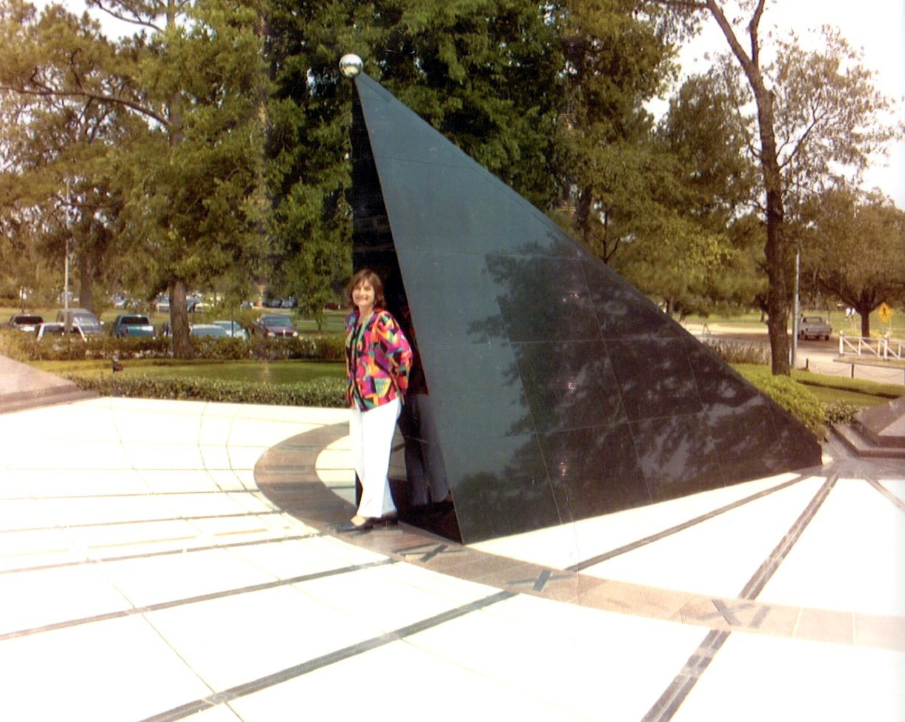

The radial lines emanating from the South point give the hour of the day in Central Mean Time.
TELLING TIME WITH THE SUNDIAL
The tall black tetrahedron with the silver ball on top is called a gnomon. The position of the shadow of the ball can be used to tell the time of day and time of year on any sunny day. The black lines which fan out from the south (low) corner of the gnomon mark the hours of the day; the Roman numerals IX, X, XI, etc., represent 9, 10, 11, a.m., Central Standard Time. (During Daylight Savings Time, add one hour). The brown line that points due north marks true solar noon - which occurs, on average, at 12:21 CST in Houston.
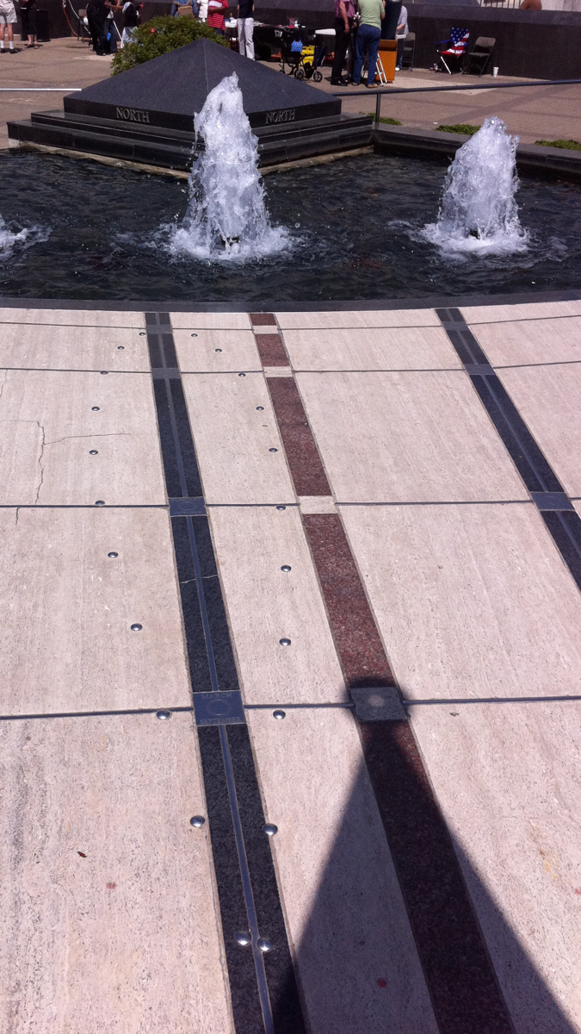

MARKING THE DAYS
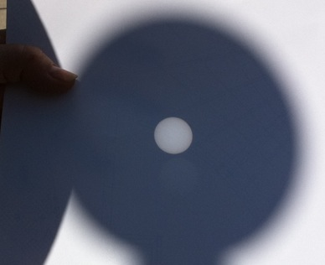
The silver curves intersecting the hour lines mark the track of the shadow of the ball on (approximately) the 21st of each month. The curve for June 21 lies closest to the ball; then July 21, Aug. 21, Sept. 22 (a straight East-West line), Oct. 21, Nov. 21, and Dec. 21 (closest to the pool). The shadow then retraces its steps back to the South, following the silver curves on the 21sts of January, February, March, April, and May. The Sun traces the silver straight line on the equinoxes.
THE ANALEMMA
If you check the sundial's time against your watch, you may find that they may disagree by as much as 16 minutes. That does not mean that your watch or the sundial is in error; it just means that the true sun isn't always at the position of the average, or "mean" sun. Because the sun changes in latitude over the course of the year, that means that it doesn't move uniformly along the Earth's equator. At some times of the year, the true sun is ahead of the mean sun; at some times the sun is behind. The largest effect is in October and November, when the sun is up to 16 minutes early; in February the sun is up to 15 minutes late. In the summer, it is more nearly 'on time'.
The analemma, shown as a figure eight of silver dots on the plaza, marks the location of true CST noon, every 10 days through the year. The sun is exactly 'on time' on December 25, April 15, June 15, and Sept 2.
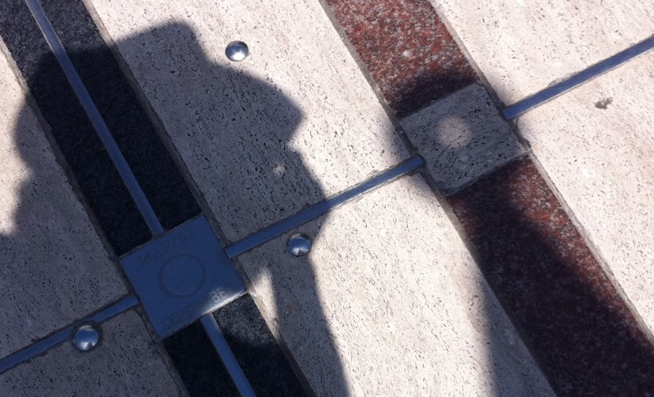
EQUINOX AND SOLSTICE ALIGNMENTS
The holes in the ball cast an image of the sun at solar noon near the solstices and equinoxes. The best time to see this is 12:28 CST in March; 1:23 CDT in June and July; 1:14 CDT in September, and 12:19 CST in December and January. Hold a white card in the shadow of the ball, about a foot off the ground, and move it up or down until the sunspots come into focus.

