ECLIPSE TIMELINE
BE SURE YOU HAVE WHAT YOU NEED FOR FUN AND SAFETY!

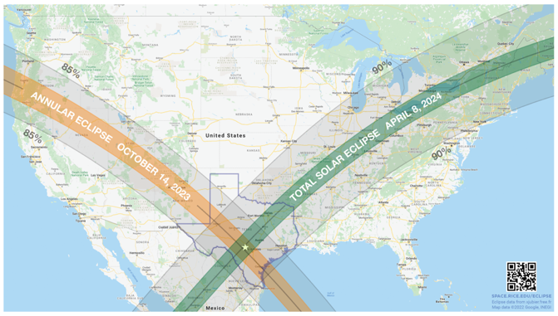
Two years ahead:
- Investigate locations in the zone of totality that you can get to, preferably with some ability to move in the final few days. (Not too close to the edge of totality, preferably in the middle 2/3). Reserve lodging if possible.

One year ahead:
- Reserve lodging if you haven’t already (most online sites open a year ahead)
- Buy plane tickets (ditto) – try to stay overnight two nights before and also the night after to avoid traffic. Allows you to do a “day before” test.

Six months ahead:
- Reserve if using a campsite - most campsites open up reservations 6 months ahead.
- Reserve a rental car if you will need one – they *will* run out
- Check out the timing for your site:
In cities see timeanddate.com/eclipse/ or https://eclipse2024.org/eclipse_cities/
For a Google map, go to https://www.timeanddate.com/eclipse/map/2024-april-8 and zoom in to your location.
Or use xjubier.free.fr, but be sure to donate to his PayPal, and his times are in UNIVERSAL TIME – subtract 5 hours for CDT, 4 hours for EDT, etc.).
Or download Stellarium from stellarium.org and put in your latitude/longitude and preview your sky view!
- 1st Contact: start of partial phase (will last over an hour)
- 2nd Contact: start of totality
- 3rd Contact: end of totality (note how much time in totality you will have – try for at least 2 minutes, preferably more)
- 4th Contact: end of partial phase (will last over an hour)

Two months ahead:
- Go to your site and check out placement of your viewing area. Be sure it does not have lights that will turn on at dusk. Check the altitude and azimuth of the Sun at totality (same sites). See if you can put something interesting into the field of view with the eclipsed Sun. Be sure you will not be near roads with headlights coming into your view. Be sure you have permission of the land owner.
- Find the exact timing for your site: (see above)
- Don’t have reservations yet? You may still be able to find camp sites, or hotels just outside the path of totality. Check on the various solar eclipse groups on Facebook. Many still have space availability for folks who are self-contained (“boondockers”).
- Buy binoculars, binocular tripod adapters, a sturdy tripod that can tip up enough for the Sun (in Texas it will be nearly 70 degrees above the horizon!), special filters for your binoculars, cameras and video cameras. Buy extra SD cards and batteries for your equipment, special eclipse glasses or viewing cards, and special eclipse binoculars if desired (I prefer regular binoculars on a tripod). For short totalities, every person should have their own pair of unfiltered binoculars (even if inexpensive) ready for totality – that is by far the best view. Buy a whistle or horn to note totality beginning and end.
- Check out you hats, jackets, water bottles, etc. A comfy lawn chair that will let you tilt back is great. If you are flying in, buy a table and camp chairs at a local hardware store.
- Make a checklist of everything you are taking so you don’t forget at the last moment. Bring a white sheet to lay on the ground to view shadow bands, and a white cardboard punched with your location and day to take a photo of its shadow with the punches making tiny eclipses. Bring some big trash bags to cover your equipment if it starts to rain or blow dust.
- Check your solar filters! Examine your filters (glasses, cards, removable filters for camera lenses, etc) for scratches, holes, and creases - throw them away if damaged! Take your filters and look through them at a very bright room light. You should see NOTHING! Now, take them and look into a very bright video projector - you should see ONLY the lit filament. Finally, take them outside and look at the sun. If it seems painfully bright, do not use them for direct viewing - they might be ok for cameras. Solar filters and glasses from 2017 should still be fine IF they were well cared for and IF they were not fakes. In 2017 there were many fake solar eclipse glasses sold. A friend of mine at Southwest Research Institute in San Antonio tested a batch that they had ordered, and they allowed a dangerous amount of UV through. So stay with reputable brands, and look for the ISO certification!
AAS has a listing of reputable vendors: https://eclipse.aas.org/eye-safety/viewers-filters.
- If planning on photography or videography, order telephoto lenses, extra SD cards, extra battery, etc. See the excellent writeup at MrEclipse.com on photography tips.

Six weeks and two weeks before:
- Try your cameras photographing the full Moon. Be sure you can manually change the exposure and manually set the focus on infinity. (most cameras will overexpose). Be sure to turn the flash OFF or tape over it. Remember the brightness will be about the same as the full Moon but the eclipse will extend more than 3 times the diameter, so don’t have too large of a focal length for your lens – 300 to 500 is good, and you won’t need tracking if you have a good tripod and fast ISO setting. Always bracket the exposure.

One week before:
- Check the weather report. Will moving a few hours one way or another help the weather? Note high thin clouds will get thinner and more transparent when totality is near, but thunderstorms are eclipse killers. Consider plan “B” if you can be mobile. You will certainly still get dark but no corona.
- Set out all your equipment ready to pack. Double check your list, and check your filters for damage (see above).

Travel day:
- Be prepared for crowds and missing reservations. Breathe deep, you got this.

One day before:
- Do a full-up test of equipment and timing from your site. Note how high and in what direction the Sun will be. (See, I told you to stay two nights before if possible).
- Be sure all filters are on the SUN end of the binoculars, lenses, or cameras – NOT on the eyepiece ends.
- Think about placing one of your smart phones where it can see your group and maybe the eclipse as well, so can record your reactions to totality. That is a video you will replay for years.
- Fill up water bottles and charge up all batteries. Get a good night’s sleep if you can!!

Eclipse Day:
- If you didn’t spend the night at your eclipse site, give yourself at least 3-4X the normal driving time to get to your site. The traffic will be insane. Be prepared if some other group arrived first and found your perfect site. (This is where your conversation with the land owner will help). Be charitable, though, everyone can see it.
- Set up the equipment; lay out the sheet. See if someone will volunteer to take temperature measurements (be sure the thermometer is in the shade).
- Don’t worry too much about getting the perfect picture – others will do a better job. Just ENJOY IT!

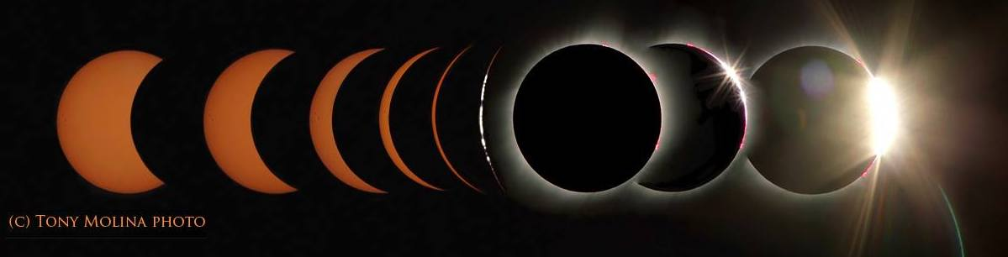

(FIRST CONTACT): Partial Eclipse begins
- You might want to take a sequence of partial eclipse photos (every five minutes or so. Be aware of other photographers in your area… don't stand in front of their cameras or telescopes.

20 minutes before second contact: REMAIN IN YOUR LOCATION.
- NO DRIVING or walking around – you might disturb other folks’ photos or trip over equipment. RED FLASHLIGHTS ONLY!
- It will get dark, even if cloudy! Photographers with tripods may use protected area.
- Take photos of the partial eclipse projected under trees, under colanders, under your punched card, etc. (You can do this also after totality)

5 minutes before second contact:
- Watch for shadow bands. Note the animal/bird behavior.

2 minutes before second contact:
- If you have a camera or video camera with an LCD panel viewer (NOT an optical viewfinder with a direct view of the Sun), you can take off your filter on it a minute or two ahead (do NOT take off filters on anything you are viewing using your eyes). You can monitor that view and take photos of the diamond ring and Baily’s beads. When the Baily’s beads disappear and the corona comes out, then you know it is safe to take off the filters on your binoculars and telescopes.

1 minute before second contact:
- Instead of looking at the Sun through filters, about a minute before totality, look to the southwest (the direction the shadow is coming from). If you are fortunate and near local noon, it will appear as a dark tornado approaching at 1000mph from the southwest. It will rapidly get wider and wider until it engulfs you.
- Once you are fully engulfed by the shadow, you will be in totality and can then look up to the Sun with your naked eyes. WOW!

SECOND CONTACT: TOTALITY!!!
- Once totality starts, you can you take off your filters and use your naked eyes and unfiltered binoculars and telescopes to view the corona. AMAZING!!
- Look around and see the sunset all around you.
- If you have a long totality, you can even stage a photo – you holding the eclipsed Sun or something like that. But don’t spend totality behind a camera – enjoy it!
- Take a sequence of photos at various exposures… short exposures get the inner corona and prominences, longer exposures get the outer corona but the inner corona is overexposed.
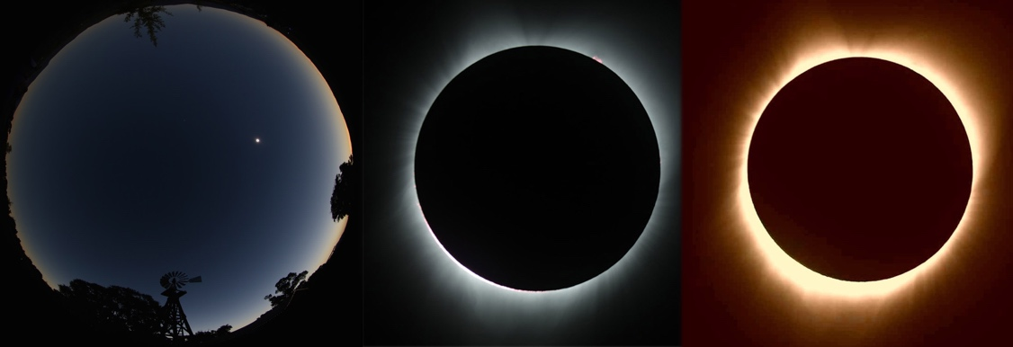

30 seconds before 3rd CONTACT: (still in totality)
- Watch for the edge of the Sun away from the Moon’s motion start to brighten. Look for “Baily’s Beads”, the red buttons of chromosphere peeking through the valleys on the edge of the Moon. Grab a photo if you can.
- Immediately afterwards, the Sun will peek through the deepest valley – the
Diamond Ring (again a great photo)
- Once the diamond ring starts to appear, COVER UP and no longer look at the Sun through your naked eyes or unfiltered telescopes or binoculars. You can see it on your LCD panel for a few seconds before covering up your camera. (Cameras will heat up if left looking at the Sun unfiltered, so keep it short).

A minute or two after 3rd CONTACT: (no longer in totality – all devices covered up)
- Watch for shadow bands on your sheet or the pavement (diffraction around the edge of the Sun).
- Take more fun eclipse pinhole photos in the shadow of trees, straw hats, etc.
- Continue to monitor animal behavior and temperatures.

4th CONTACT: (end of partial eclipse)
- Continue to monitor animal behavior and temperatures.
- Pack up equipment and be courteous to the folks around you. Drive safely!

